<https://www.udemy.com/course/the-complete-web-development-bootcamp/learn/lecture/12383928#questions/12105158>

Creating a drum set for this section

Provided starter files

Add event listener to buttons-querySelectorAll results in node list that is array like, use for loop to add event listener to the drum buttons

Event target add event listener method

<https://developer.mozilla.org/en-US/docs/Web/API/EventTarget/addEventListener>

Event reference

<https://developer.mozilla.org/en-US/docs/Web/Events>

addEventListener takes in 2 required arguments or inputs and one optional – the type of event and function

Can pass a function into a function

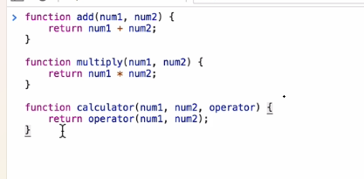



Playing sound with JS

      new Audio("./sounds/crash.mp3").play();

<https://developer.mozilla.org/en-US/docs/Web/API/HTMLAudioElement>

<https://stackoverflow.com/questions/9419263/how-to-play-audio>

switch statement

onkeyup

javascript objects , dot notation

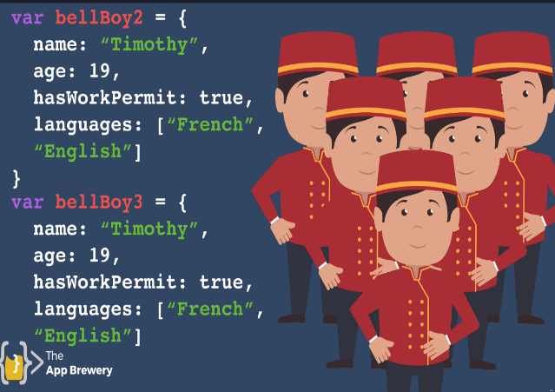

Constructor is like a factory to make more objects

<https://www.w3schools.com/js/js_object_constructors.asp>

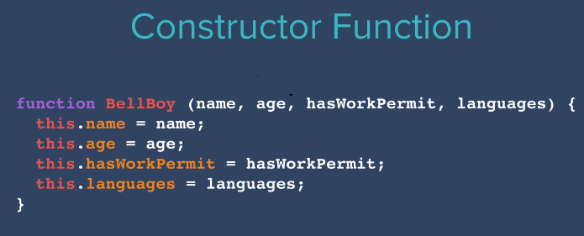

To use it

Objects can also have methods

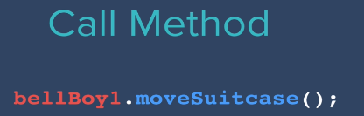

Method added to constructor

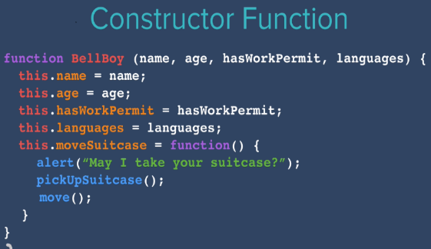

Call backs

Set time out

Why is requestAnimationFrame better than setInterval or setTimeout -

<https://stackoverflow.com/questions/38709923/why-is-requestanimationframe-better-than-setinterval-or-settimeout>

From Geeks for geeks <https://www.geeksforgeeks.org/settimeout-vs-requestanimationframe/#>

Restart here

<https://www.udemy.com/course/the-complete-web-development-bootcamp/learn/lecture/12384170#questions/12105158>